**Github configuration for Dataform (Bigquery)**

1-Create the Git repository in the Bayer environment

- Created repository : <https://github.com/bayer-int/smarthub-dataform-poc.git>

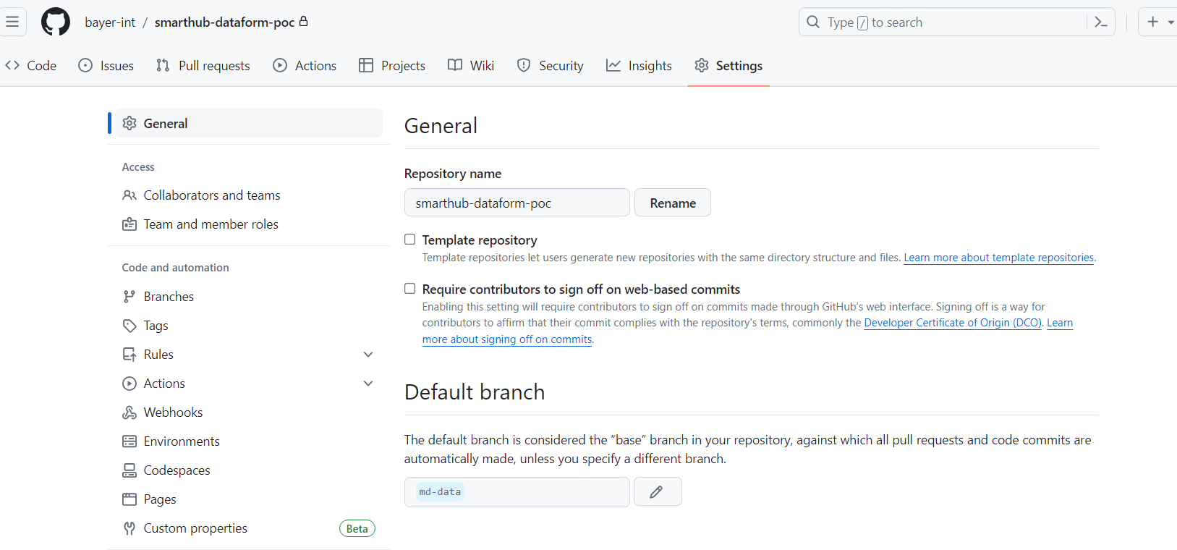

2-Create a token on Github to be used in GCP

- Created a token like this

a) Settings

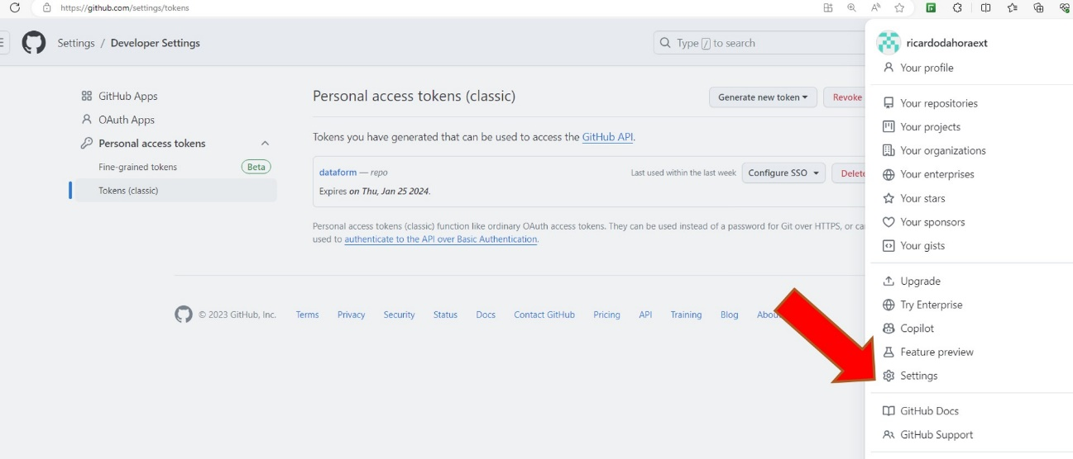

b) choose options developer settings

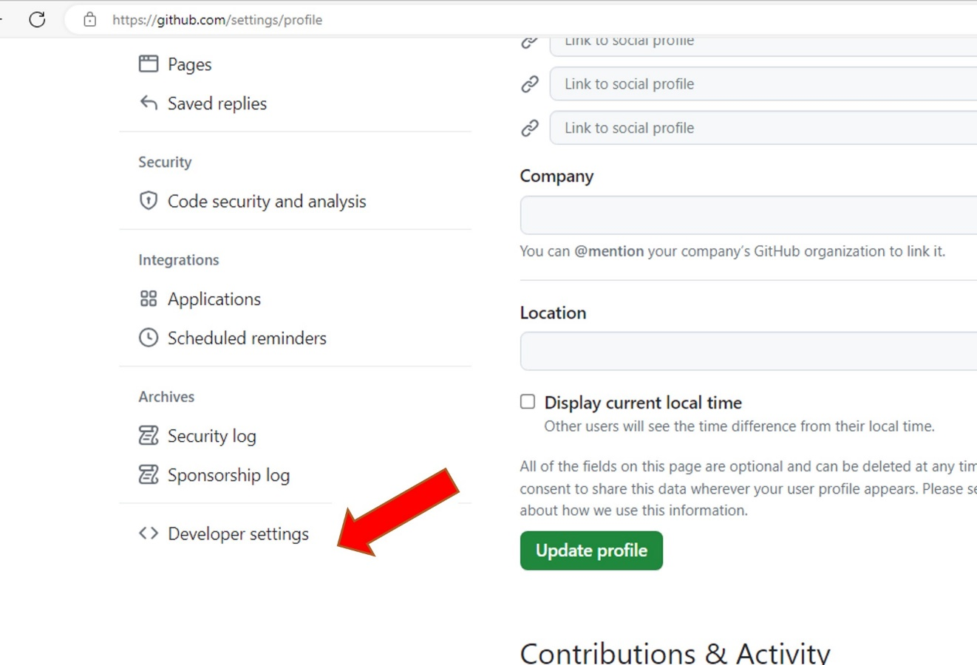

c) Choose Tokken Classic

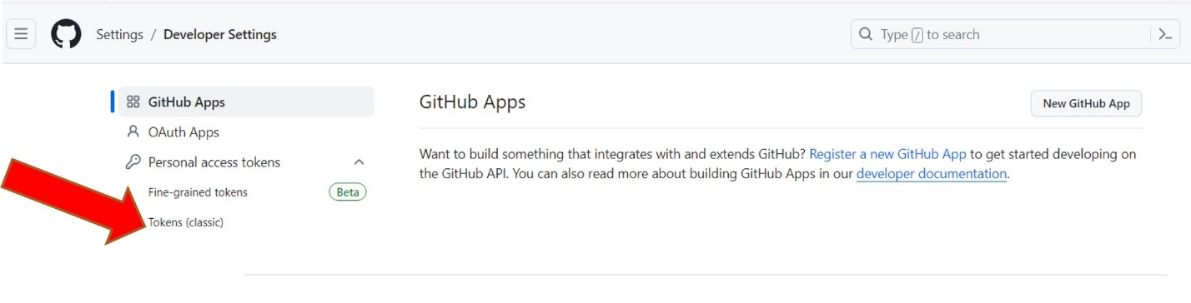

d) Click in Tokken classic

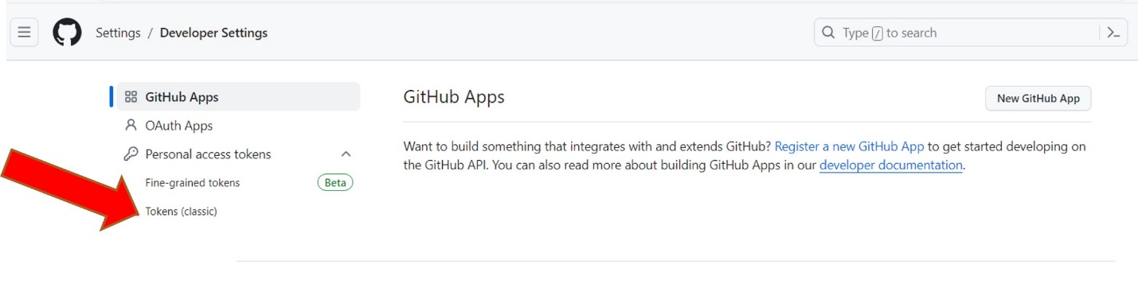

e) Generate a new token

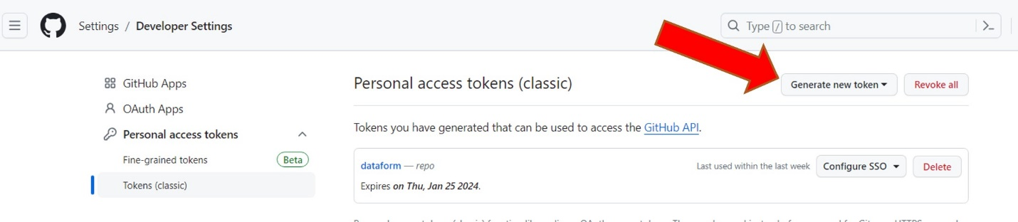

f) Create the new token with this informations

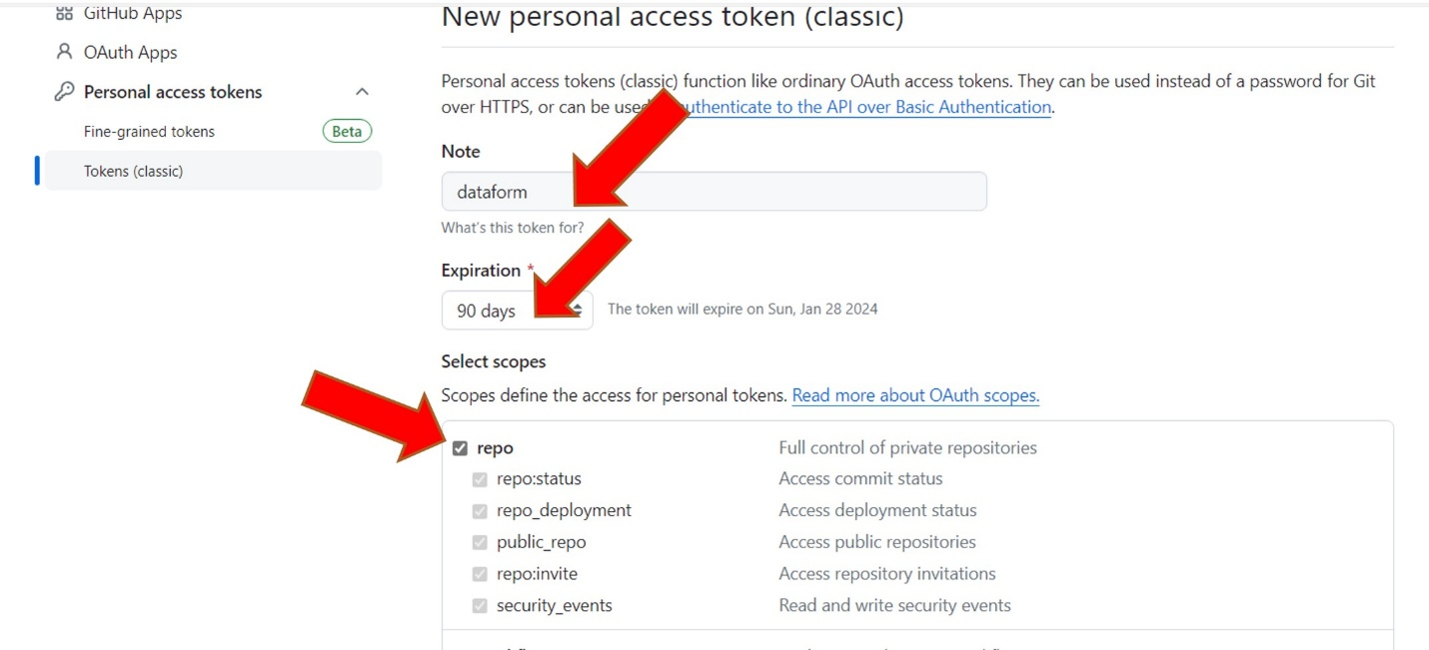

g) Copy the number generated to use in GCP

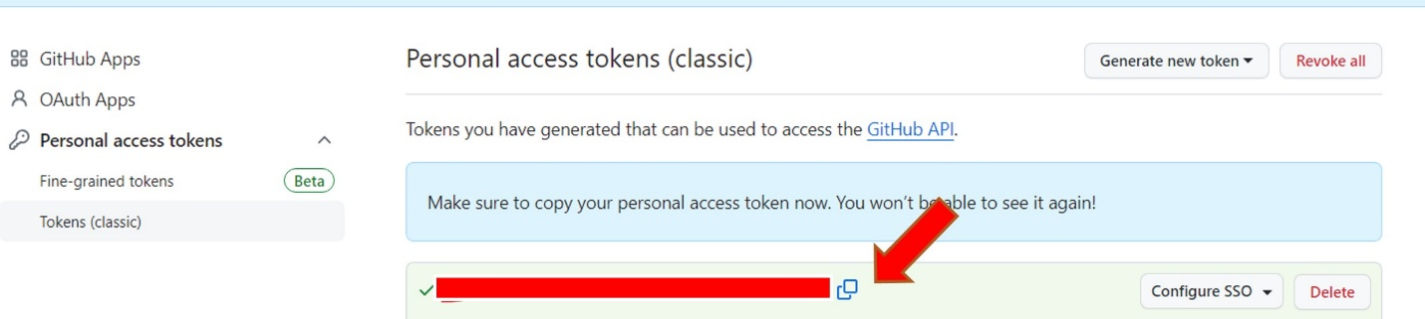

h) Configure SSO with Bayer organizations

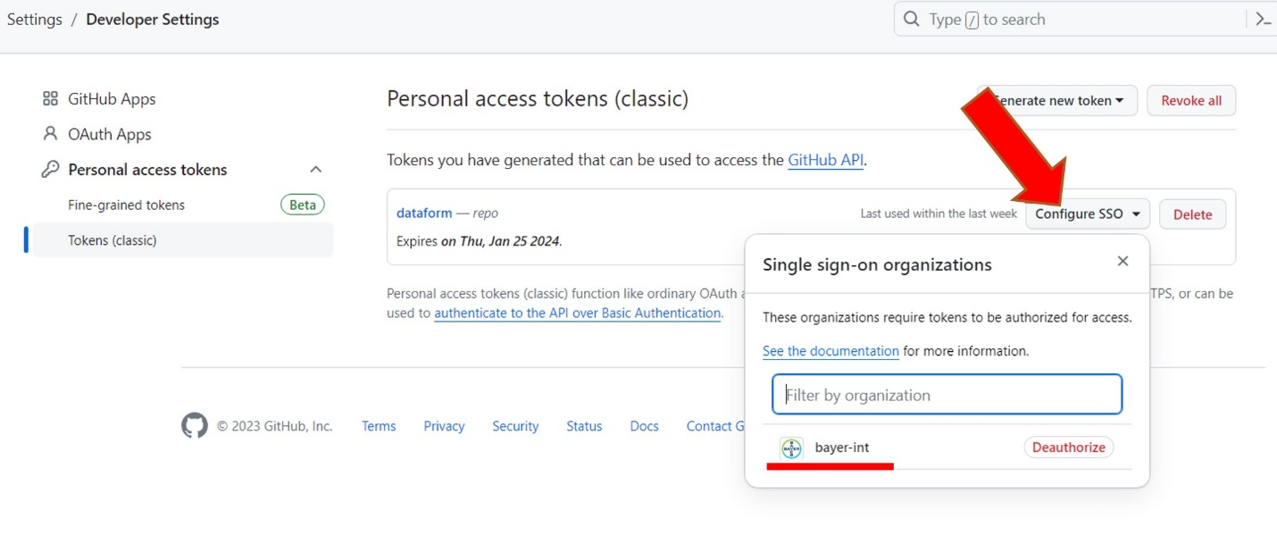

3-Create a Secret Manage with the token generated by Github

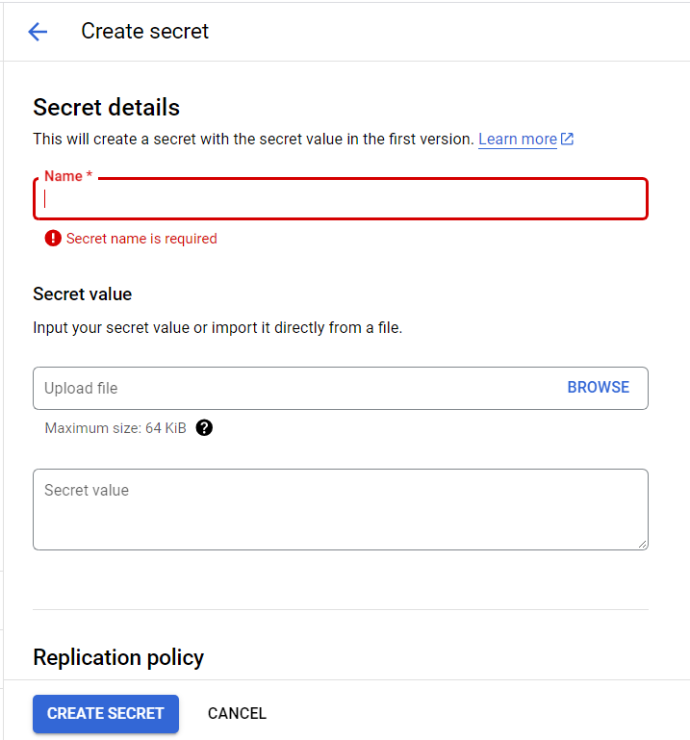

4-Create a repository in Dataform

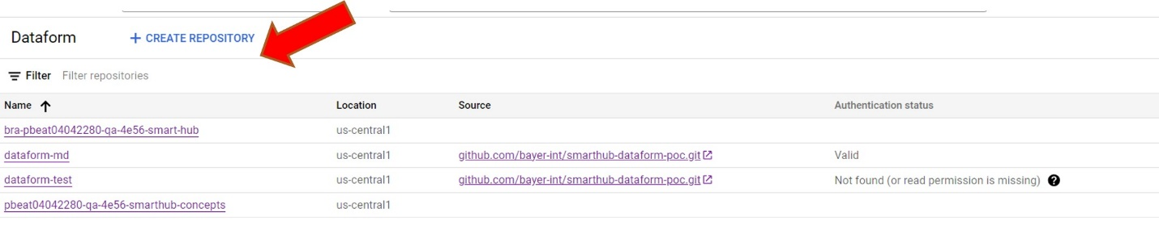

5-Configure Github for the Dataform repository with the secret manager created for the Git repository

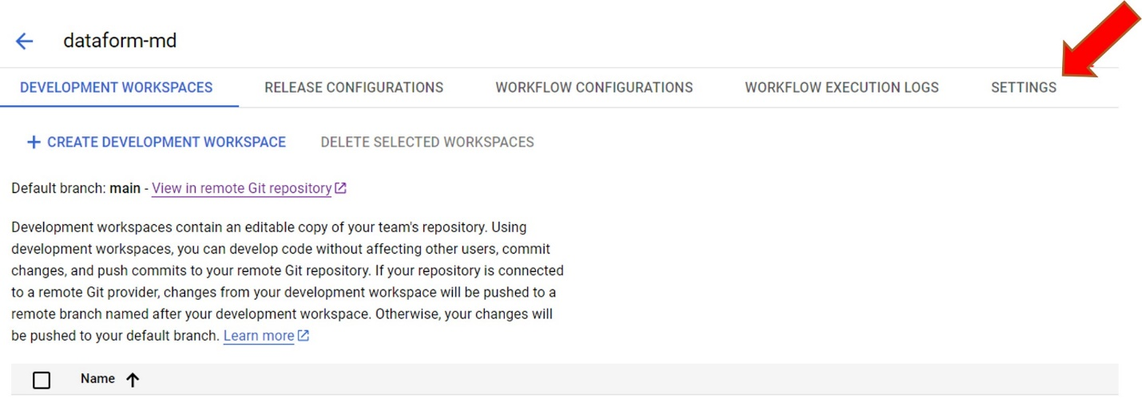

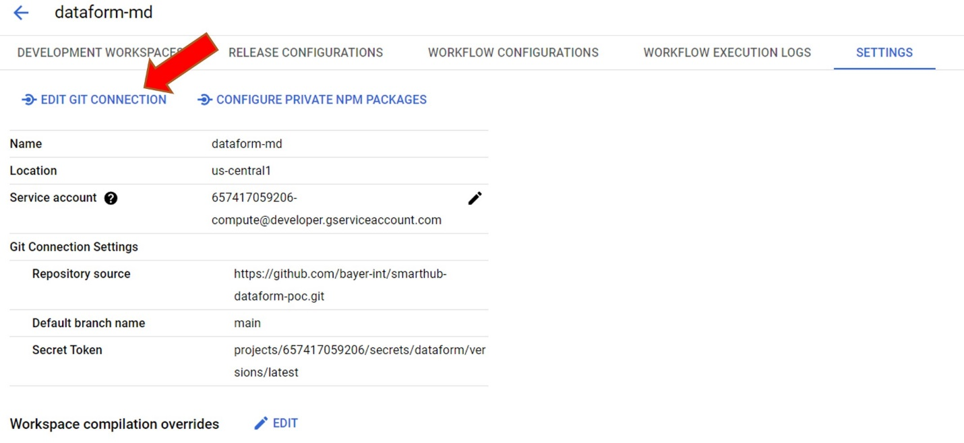

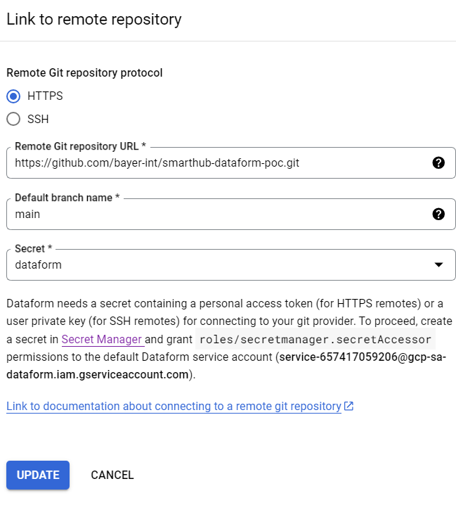

Warning!!!!

*** Dataform needs a secret containing a personal access token (for HTTPS remotes) or a user private key (for SSH remotes) for connecting to your git provider. To proceed, create a secret in [Secret Manager](https://console.cloud.google.com/security/secret-manager?project=pbeat04042280-qa-4e56-smarthub)and grant roles/secretmanager.secretAccessor permissions to the default Dataform service account (service-657417059206@gcp-sa-dataform.iam.gserviceaccount.com).

6-Create a workspace for the repository

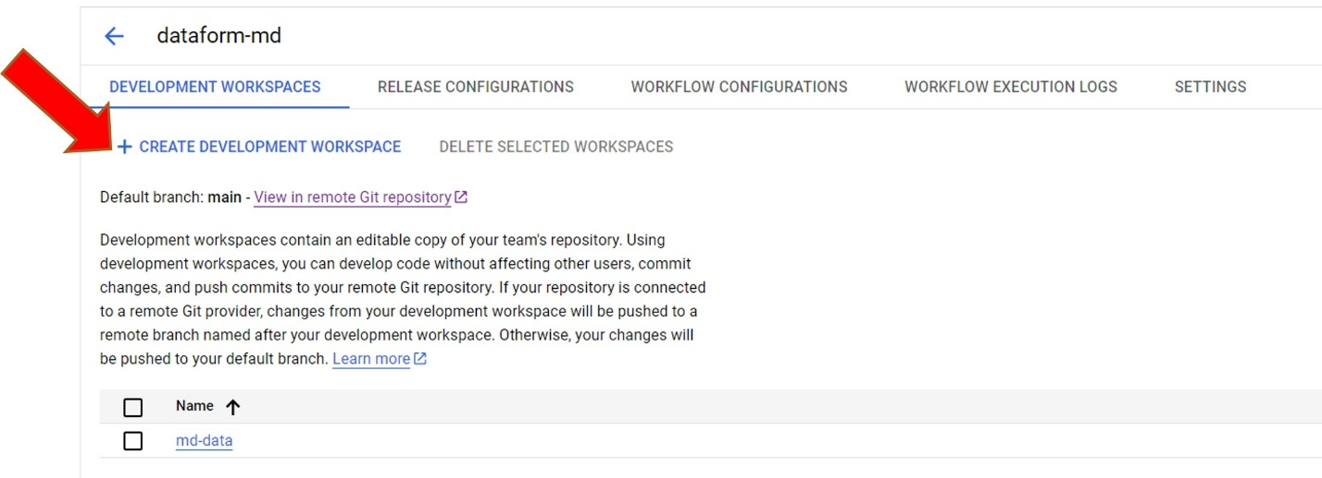

7-Sync with Github

All scripts genegerate in Dataform will be sync with GitHub . The structure of Dataform follows below.

